Assignment 6: Technical Analysis using R, Visualization Phase

Session 15:
1. Project Overview
The R Shiny dashboard demonstrates stock-price exploration and technical analysis in one interactive interface. The implementation is contained in app.R, with explanatory comments organized around data collection, interface controls, visualization, technical indicators and signal annotations.

2. Workflow Diagram
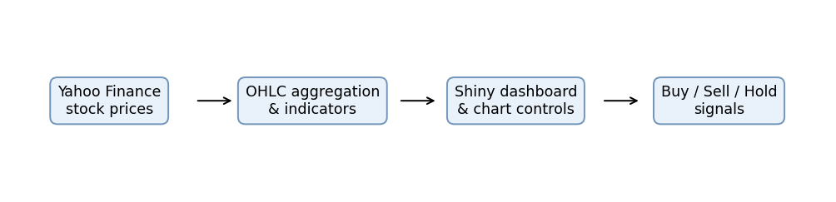
Figure 1. Data flow from Yahoo Finance through OHLC aggregation and indicator calculations to the Shiny dashboard and crossover annotations.
3. Task 1 — Collect Stock Data
The application uses quantmod::getSymbols() with the Yahoo Finance source. The ticker is entered by the user. The date input defines the visible interval, and an additional year of historical prices is requested for indicator warm-up. Download errors are handled and displayed in the interface. OHLC columns are converted into a data frame for plotting.
4. Task 2 — Interactive Price Charts
The interface includes a ticker input, date-range selector, Daily/Weekly/Monthly time-frame selector, Line/Area/Candlestick chart selector and Fetch stock data button. For weekly and monthly views, quantmod aggregates OHLC bars. ggplot2 draws closing-price line and area charts or candlestick-style OHLC bodies and wicks.
5. Task 3 — Technical Indicators
Two user-adjustable simple moving averages are computed with TTR::SMA() and displayed as overlays. RSI(14) is computed with TTR::RSI(). MACD uses fast EMA 12, slow EMA 26 and signal EMA 9. RSI and MACD are displayed in separate panels because they have different scales from stock prices. Checkboxes control whether each indicator is displayed.
6. Task 4 — Trading Signal Annotations
The code compares the short moving average with the long moving average. A Buy annotation appears when the short average crosses above the long average; a Sell annotation appears when it crosses below. All other observations are treated as Hold. Annotations identify new crossing events rather than labeling every day in an ongoing trend.

7. Code Organization
The single app.R file is divided into documented sections: package setup and helpers; dashboard UI; reactive data processing; visualizations; technical indicators; and trading signals. This follows the instruction to keep all R code in one script while clearly separating the assignment tasks.

8. How to Run
1. Install R and RStudio.
2. Run install.packages(c("shiny", "ggplot2", "quantmod", "TTR")).
3. Open app.R and click Run App.
4. Enter a Yahoo Finance symbol such as AAPL and select dates.
5. Click Fetch stock data.
6. Test the chart types, time frames, indicator checkboxes, moving-average values and Buy/Sell annotations.

9. Validation and Limitations
The app must be executed in RStudio before submission. Confirm that data download works, all three chart types render, weekly/monthly resampling is correct, indicators toggle, and crossing labels are reasonable. R is not available in this working environment, so no claim of successful local execution is made. Yahoo Finance availability can change, and the trading signals are educational, not investment advice.

10. GitHub Link: https://github.com/Tejeswari-ghub/Technical-Analysis-using-R-Visualization-Phase

